PHENIKAA UNIVERSITY
PHENIKAA SCHOOL OF COMPUTING
⸎⸎⸎⸎⸎

LAB REPORT – LAB 4: MICROSERVICES DECOMPOSITION & COMMUNICATION
Topic: Building a Web-Based Library Management System
Team : Group 1
Student : Nguyễn Đăng Hiếu – 23010049
Nguyễn Trường Sơn – 23010313
Đỗ Hữu Đại 23010825
Bùi Đắc Hợp 23012022
Instructors : Vũ Quang Dũng
Class : Software Architecture(N01)

2. Abstract / Summary
This lab focuses on transitioning the Library Management System (LMS) system from a monolithic layered architecture to a Microservices Architecture. The primary objective is to decompose the system based on business capabilities, define clear service boundaries, and design communication strategies among independent services.
Key deliverables include identifying core microservices, specifying service contracts (API endpoints), and modeling system interactions using the C4 Model (Level 1 – System Context). This design-oriented lab provides a foundational blueprint for implementing scalable, maintainable, and loosely coupled microservices in subsequent labs.

3. Lab Specific Section: Microservices Decomposition & Communication

3.1 Decomposition by Business Capability
The Library Management System (LMS) system is decomposed into independent microservices based on core business domains identified from Lab 1 requirements.
Business Capability | Proposed Microservice | Data Owned
User Management | User Service | User profile, authentication credentials
Book Catalog Management | Book Service | Book details, pricing, images
Borrowing Management | Borrowing Service | Cart items, session state
Order Processing & Tracking | Borrowing/Returning Service | Orders, order items, shipping address
Inventory Management | Inventory Service | Stock levels, warehouse data
This decomposition ensures loose coupling and high cohesion, allowing each service to operate and scale independently.

3.2 External System Dependencies
Library Management System (LMS) interacts with several external systems to support its business processes:
- Fine Payment Gateway: Handles online payment processing
- Email/SMS Provider: Sends order confirmations and notifications
- Shipping Carrier API: Provides shipping and delivery tracking information
These systems are accessed via well-defined interfaces to maintain system modularity.

3.3 Service Contracts (API Specifications)
This section defines service contracts with a focus on interaction between Book Service and Borrowing Service.

3.3.1 Book Service API
Endpoint | HTTP Method | Description | Data Returned
/api/products/{id} | GET | Retrieve product details by ID | Book (name, price, description)
/api/products | GET | List/search products | List of products (summary)
/api/products | POST | Add new product (Admin only) | Created product object

3.3.2 Borrowing Service Interaction
When a user adds a product to the cart, the Borrowing Service must retrieve the product name and price from the Book Service using the API endpoint:
- GET /api/products/{id}
Direct database access between services is strictly prohibited to preserve microservice boundaries.

3.4 Communication Strategy
Interaction | Services Involved | Communication Type | Rationale
User Login | API Gateway → User Service | Synchronous (HTTP) | Immediate response required
Inventory Check | Borrowing Service → Inventory Service | Synchronous (HTTP) | Stock must be verified instantly
Order Confirmation | Borrowing/Returning Service → Email Provider | Asynchronous (Message Queue) | Email sending should not block order flow

3.5 System Modeling: C4 Model (Level 1 – System Context)
The C4 System Context Diagram illustrates the Library Management System (LMS) as the central system and defines its interaction boundaries with users and external systems. The primary actors of the system include Reader, Librarian, and Administrator, who interact with the LMS to perform book searching, borrowing–returning operations, and system administration.
In addition to internal users, the LMS integrates with external systems to support non-core functionalities. The Fine Payment Gateway is used to process overdue fine payments, while the Email/SMS Notification Service is responsible for delivering borrowing confirmations, reminders, and overdue notices. This system context model provides a high-level overview of the LMS environment, clearly identifying system responsibilities and external dependencies without exposing internal implementation details.
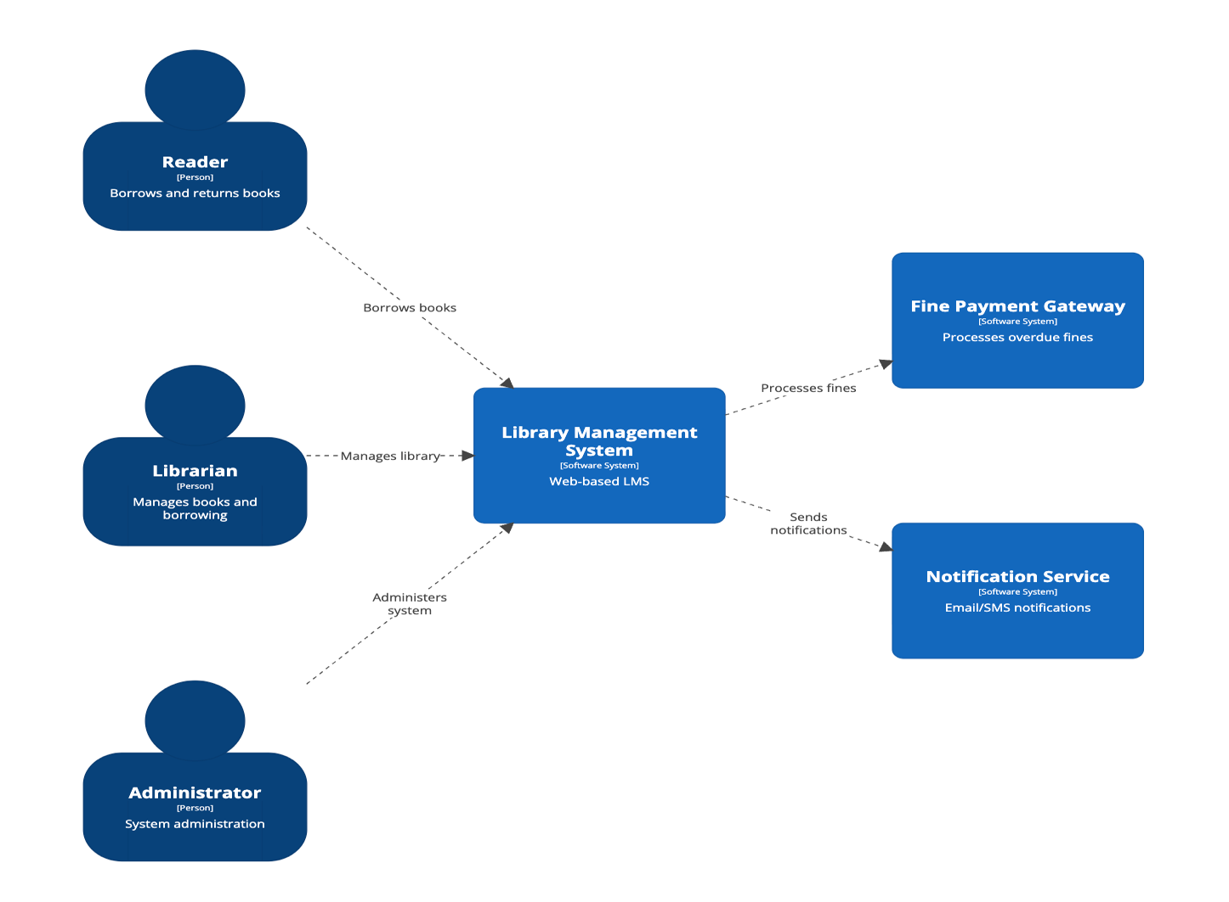
C4 System Context Diagram – Library Management System

4. Architectural Impact (Preparation for Next Lab)

4.1 Architectural Problem Statement
The challenge is to design an architecture that supports scalability, independent deployment, and resilience while maintaining data consistency and security across distributed services.

4.2 Impact of Microservices on Architecture
- Scalability: Individual services can scale independently based on demand
- Reliability: Failure in one service does not bring down the entire system
- Modifiability: New services or features can be added with minimal impact on existing services
These considerations will guide the detailed microservices design and implementation in subsequent labs.

5. Conclusion & Reflection
Lab 4 successfully establishes a microservices-based architectural blueprint for the Library Management System (LMS) system. Through systematic decomposition, clear service contracts, and well-defined communication strategies, the system is prepared for scalable and maintainable development.
The C4 System Context Model provides a clear overview of system interactions, while the defined APIs enforce proper service boundaries. This lab lays the groundwork for implementing and integrating microservices in future stages of the project.

